Kingston & Surbiton Conservative Association

Friday 24th November 2023 7pm to Midnight
Glenmore House, 6, The Crescent, Surbiton, KT6 4BN
Full Name:

Email:

Phone:

No. of People:
6.
7.
8.
9.
10.
1.
2.
3.
4.
5.
(@ £80 per person)

Allergies:

Dietary Requirements:
(Pescatarian / Vegetarian / Vegan)

Payment by Bank Transfer
Reference: KSCADB23
NAME: Kingston and Surbiton Conservative Association
SORT CODE: 30-99-50
ACCOUNT: 85030860
Or by Cheque made out to Kingston and Surbiton Conservative Association
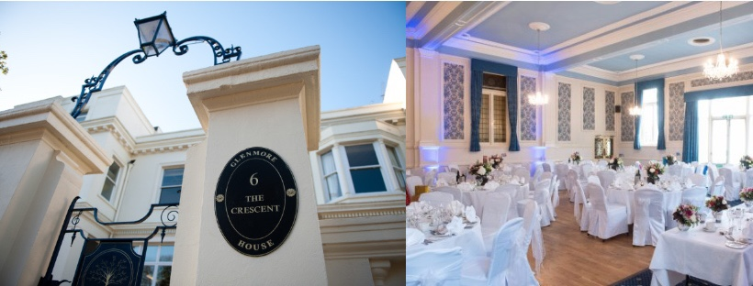
If paid by Bank Transfer, please email form to: KSCAevents23@gmail.com

